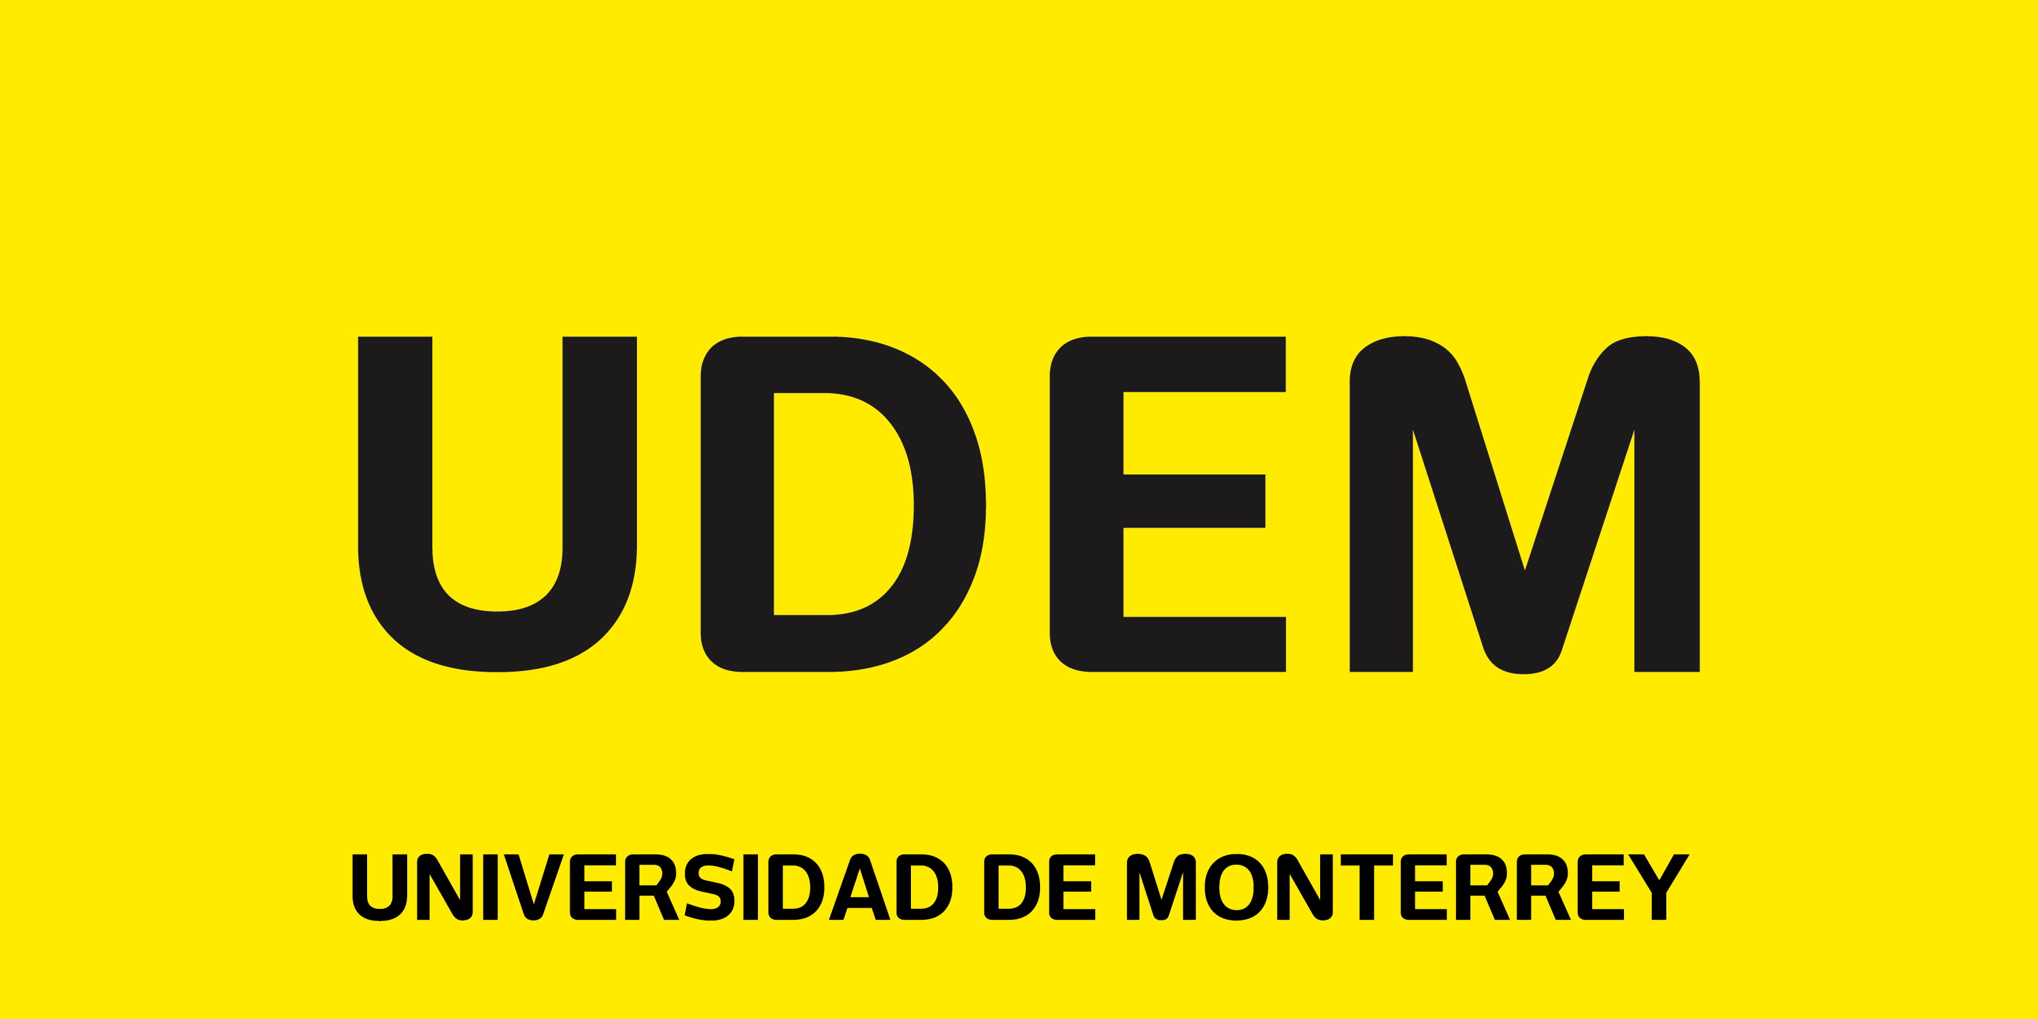


6th Global Business and Human Rights Conference

Universidad de Monterrey
3-4 September 2020

Conference Program

NB. Please note all times are GMT-5 (Monterrey, Mexico-CDT)

3 September 2020

10:00-10:45 (Zoom Webinar: https://udem.zoom.us/j/95063877930)
Welcoming remarks
Arturo Azuara, Dean, School of Law and Social Sciences, UDEM
Anita Ramasastry & Tara Van Ho, Co-Presidents, Global BHR Scholars Association
Humberto Cantú Rivera, Conference Chair

11:00-13:00

Cohort One (https://udem.zoom.us/j/96051501508, Password: 829897UDEM)

Moderator: Kish Parella, Washington and Lee University School of Law
Secretariat: Henrietta Dorfmüller, PhD(c), University of St. Gallen

Marisa McVey (University of St. Andrews, Scotland): Traduttore, Traditore? Translating Human Rights into Corporate Context through the UN Guiding Principles on Business and Human Rights
Discussant: Sorcha MacLeod & Nelleke van Amstel

Sorcha MacLeod (University of Copenhagen, Denmark) & Nelleke van Amstel (University of Geneva, Switzerland): Gendered Human Rights Impacts in the Private Military and Security Sector
Discussant: Basak Baglayan

Basak Baglayan (Université du Luxembourg): Great Expectations: Remedy Through OECD “Specific Instance” Procedure
Discussant: David Hess

David Hess (University of Michigan): Addressing Modern Slavery in Global Supply Chains: Towards a Legislative Solution in the United States
Discussant: Marisa McVey

Cohort Two (https://udem.zoom.us/j/91480838704, Password: 508093UDEM)

Moderator: Penelope Simons, University of Ottawa
Secretariat: Rose Wangi Kimotho, PhD(c), University of St. Gallen

Sabrina Rau (University of Essex, United Kingdom): With Great Reliance Comes Great Responsibility: The Role of Technology Companies during Covid-19
Discussant: Claire Bright

Claire Bright (Nova School of Law, Portugal): Overcoming the Private International Law Hurdles to Access to Remedy in Business-Related Human Rights Claims Brought in the EU: The Issue of Jurisdiction
Discussant: Judith Schönsteiner

Judith Schönsteiner (Universidad Diego Portales, Chile): Double standards and human rights due diligence in global aquaculture supply chains
Discussant: Chiara Macchi

Chiara Macchi (Wageningen University, The Netherlands): Integrating Climate Change into the notion of Human Rights Due Diligence
Discussant: Ana Claudia Ruy Cardia Atchabahian

Ana Claudia Ruy Cardia Atchabahian (Mackenzie University, Brazil): Transterritoriality as a New Theory to Hold Corporations Accountable for Human Rights Violations
Discussant: Sabrina Rau

4 September 2020

08:00-09:00 (Zoom Webinar: https://udem.zoom.us/j/93880911644)
6th Global Business and Human Rights Conference Roundtable
Michael K. Addo, University of Notre Dame
Surya Deva, City University of Hong Kong
Beata Faracik, Polish Institute for Business and Human Rights
Danielle Pamplona, Pontificia Universidade Católica do Paraná
Florian Wettstein, University of St. Gallen

Moderator: Humberto Cantú Rivera, Universidad de Monterrey

09:15-11:45

Cohort One (https://udem.zoom.us/j/97099026151, Password: 588036UDEM)

Moderator: David Hess, University of Michigan – Ross School of Business
Secretariat: Sandra Souto, PhD(c), University of St. Gallen

David Birchall (City University of Hong Kong): Reconstructing State Obligations to Protect and Fulfil Socio-Economic Rights in an Era of Marketization
Discussant: Audrey Lebret

Audrey Lebret (University of Copenhagen, Denmark): Human Rights Due Diligence and Medical Artificial Intelligence
Discussant: Muhammad Asif Khan

Muhammad Asif Khan (Bahria University, Pakistan): The Effects of Military Owned Business Entities in Pakistan on a Right to Fair Competition and Due Process of Law
Discussant: David Birchall

Diana Guarnizo-Peralta (DeJusticia, Colombia): Marketing of unhealthy products towards children in Latin America: Human right’s duties for states and businesses
Discussant: Kishor Dere

Kishor Dere (Jawaharlal Nehru University): Impact of Artificial Intelligence (AI) Industry on Human Rights
Discussant: David Birchall

Cohort Two (https://udem.zoom.us/j/97672344087, Password: 188191UDEM)

Moderator: Humberto Cantú Rivera, Universidad de Monterrey
Secretariat: Alejandro Sánchez González, PhD(c), UDEM

Dalia Palombo (University of St. Gallen, Switzerland): An Imperialist Project?
Discussant: Danielle Anne Pamplona

Malcolm Rogge (Harvard University): Humanity Constrains Loyalty: Towards a Theory of Human Rights, Fiduciary Duty, and the Corporation
Discussant: Dalia Palombo

Danielle Anne Pamplona (Pontifical Catholic University of Parana, Brazil) & Lincoln Zubra (Catholic University of Santa Catarina, Brazil): Tackling social dumping in the Brazilian legal system through pedagogical damages
Discussant: Rachel Chambers & Jena Martin

Rachel Chambers (University of Connecticut) & Jena Martin (West Virginia University): Civil Liability for Human Rights Violations: The Position in the United States
Discussant: Jacobo Ramírez

Jacobo Ramírez (Copenhagen Business School, Denmark): Transactional colonialism in green neoliberal investments: The struggles for human rights of indigenous people in Oaxaca regarding wind power developments
Discussant: Malcolm Rogge

11:45-12:00 (https://udem.zoom.us/j/92367541621, Password: 495093UDEM)
Closing Remarks
Anita Ramasastry & Tara Van Ho, Co-Presidents, Global BHR Scholars Association
Humberto Cantú Rivera, Conference Chair

Don’t forget to tweet! #BR2R2020

